User Acceptance Testing (UAT) Template
Date | 19 Feb 2026
Team ID | LTVIP2026TMIDS52481
Project Name | Dog Breed Identification Using Transfer Learning
Maximum Marks | 4 marks

Project Overview:
Project Name: Dog Breed Identification Using Transfer Learning
Project Description: This project uses deep learning and transfer learning (MobileNetV2) to automatically classify dog breeds from uploaded images through a web-based Flask application. The system provides fast, accurate, and user-friendly breed prediction to support pet care, veterinary assistance, and animal rescue services.
Project Version: 1.0
Testing Period: 10-Feb-2026 to 14-Feb-2026
Testing Scope:
• Image upload and preprocessing
• Dog breed prediction using trained MobileNetV2 model
• Display of prediction results on web interface
• Backend API integration and response handling
Testing Environment:
• Application Location: Local Flask server / deployed web URL
• Credentials: Not required (public prediction interface)
Test Cases:
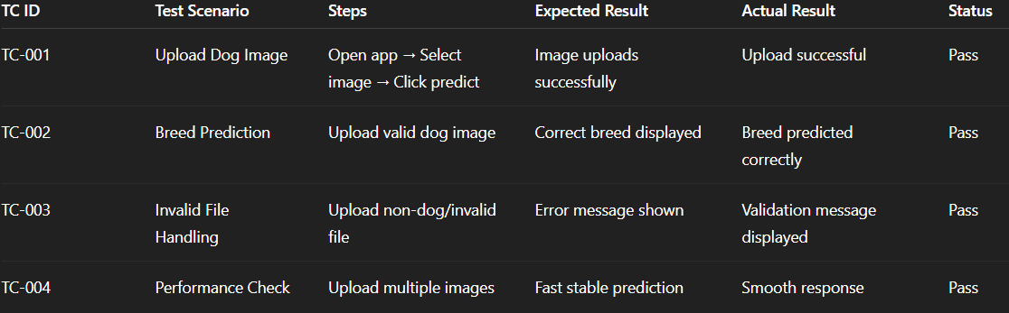

Bug Tracking:
Bug ID | Bug Description | Severity | Status | Additional feedback
BG-001 | Minor UI alignment on small screen | Low | closed | Responsive layout fixed

Sign-off:
Tester Name: Ram Sai Kumar K
Venu Madhav B
Date: 19 february 2026
Signature: Ram Sai Kumar K
Venu Madhav B
Notes:
- Ensure that all test cases cover both positive and negative scenarios.
- Encourage testers to provide detailed feedback, including any suggestions for improvement.
- Bug tracking should include details such as severity, status, and steps to reproduce.
- Obtain sign-off from both the project manager and product owner before proceeding with deployment.

